**Incident Management in HISD Connect**

**Create Detailed Incident**

**Incident Description**

Discipline incidents are created at the school or district level. If an incident occurs on school grounds, then PowerSchool recommends creating the incident while logged into the school. If the incident occurs within the district but is not related to a particular school, then PowerSchool recommends creating the incident at the district level.

Use the steps below to create a new incident and populate the Incident Description portion of the incident.

**Required for state reporting**: School, Incident Type, Incident Date, and Location.

1. Log in to PS.
2. Navigate to Start Page > Special Functions > Incident Management.
3. Click **Create Incident** and choose **Create Detailed Incident**.
4. Choose the **Incident Type**. Incident types are displayed based on security rights.
   1. For state reporting, the Incident Type must = Discipline^
   2. For Civil Rights Data Collection reporting of allegations of Bullying or Harassment that do not result in a discipline action, the Incident Type must = CRDC Victim^.
5. Populate the **Incident Date** and **Time**based on when the incident occurred.
6. Choose the **Time Frame**. This field is not required for state reporting but can be used for local use. You can set up your district Time Codes in District > Incident Management > Code & Subcode Setup.
7. Enter the **Title** and **Description** of the incident. The Description is recommended but is not required.
8. Choose the **Location,**which is required for Texas state reporting beginning with the 2019-20 year. The Location field replaces the now-obsolete Behavior Location field.
   1. When a location is chosen, an optional **Location Comment** field appears. This field allows for the input of additional detail regarding the location of the incident. The Location Comment is not collected by the state.
   2. Populate the optional **Location Description**field if desired.
9. Populate the **Financial Impact**as needed.

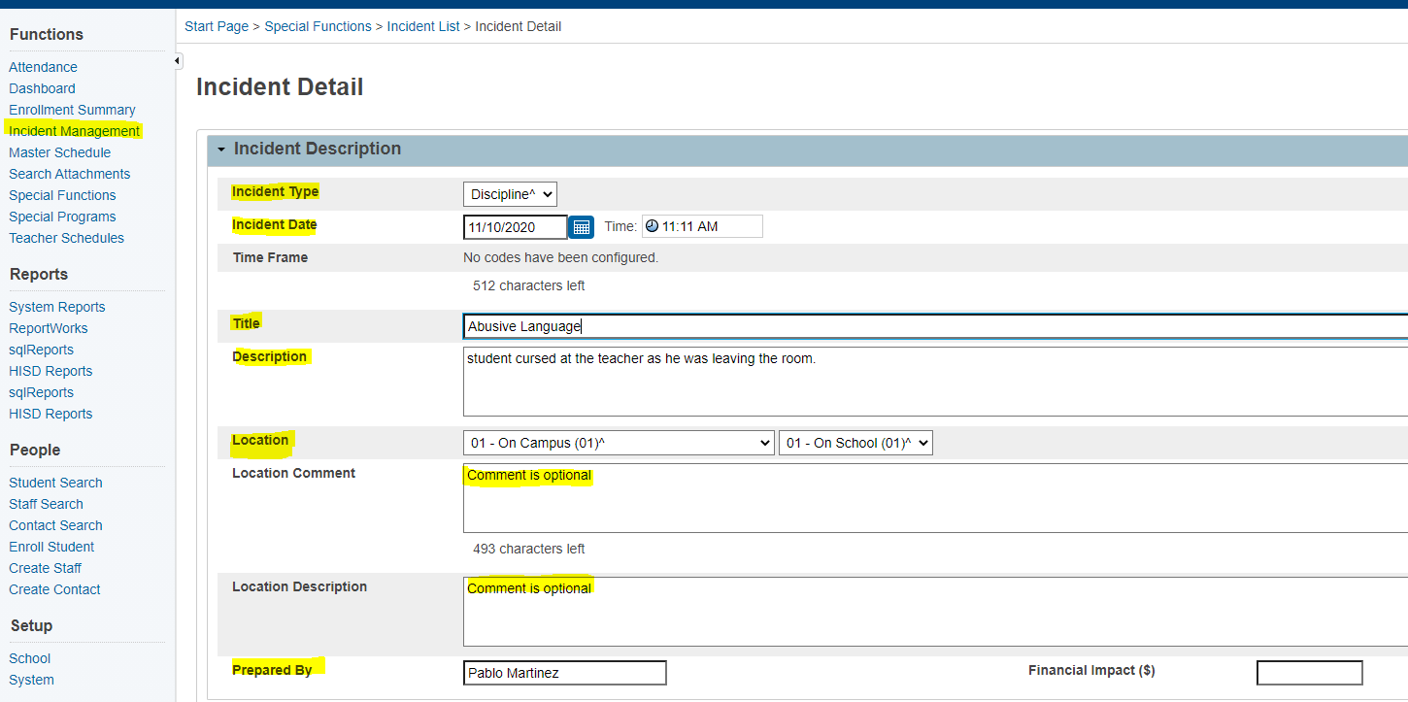

**Incident Builder - Participants**

Use the steps below to populate the Participants portion of an incident.

**Add Student and Staff Participants**

Use these steps to add a student or staff member who is in the PowerSchool system.

1. Click the **Plus (+)** button next to Participants. The Search for Student, Staff, or other Participants dialog appears.

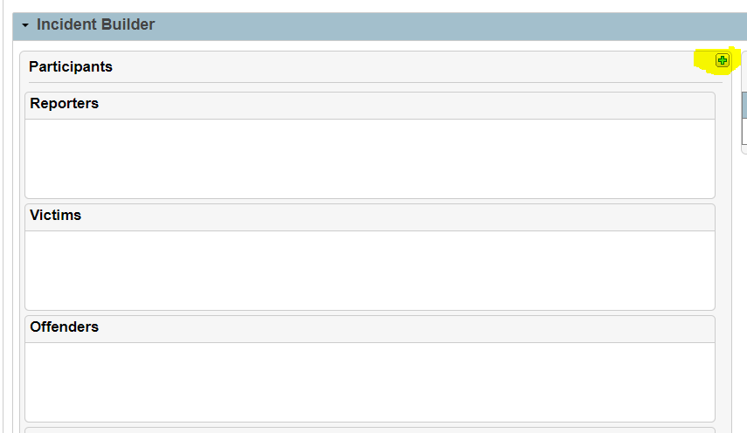

1. Enter the criteria for the search and click **Search**. The Results section is populated with matching participants.

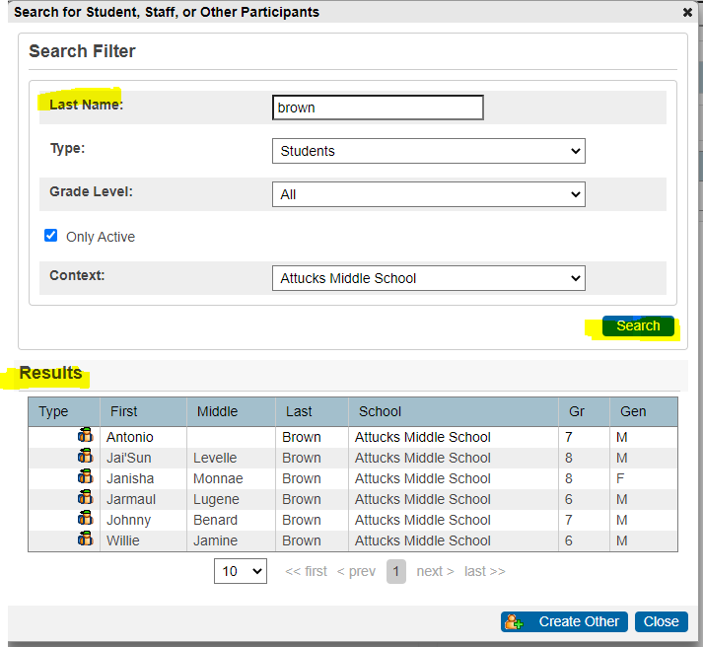 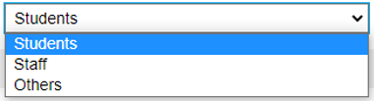

1. Highlight the appropriate participant in the search results.
2. Click **Add**.

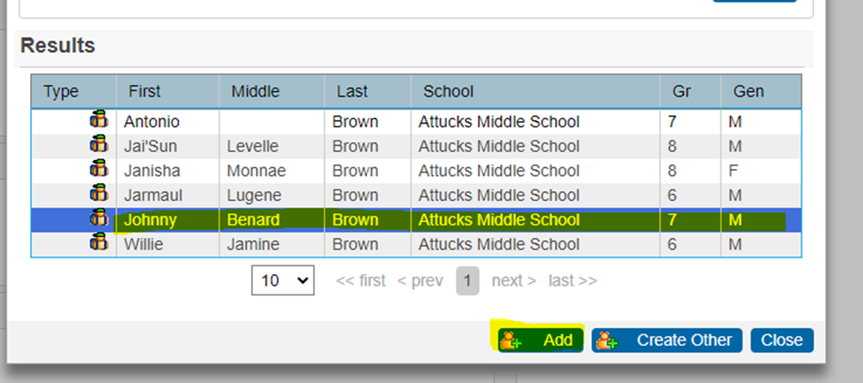

1. Choose a role from the **Select Role(s)** pop-up menu. There must be at least one student Offender for the incident to be reported.

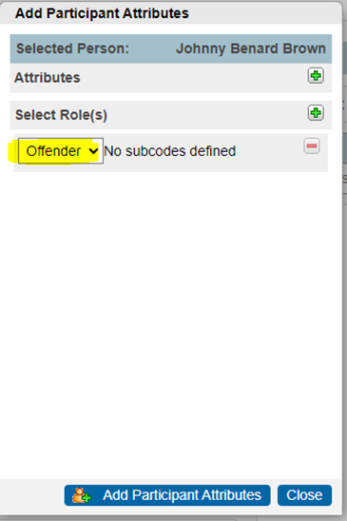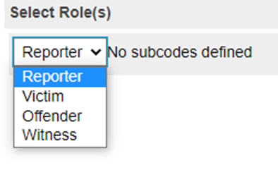

1. Click **Add Participant Attributes.**

**Incident Builder - Incident Elements**

Use the steps below to add behaviors, actions, and attributes to the incident.

***Add a Behavior***

Use the steps below to add behaviors to the incident.

**Required for state reporting**: Behavior Code

1. Click the **Plus (+)**button next to Incident Elements.

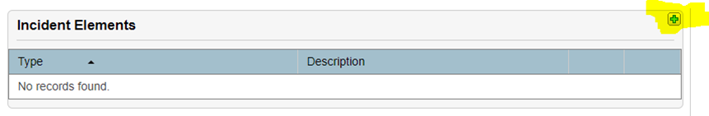

1. Choose **Add Behavior** from the pop-up menu.

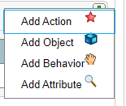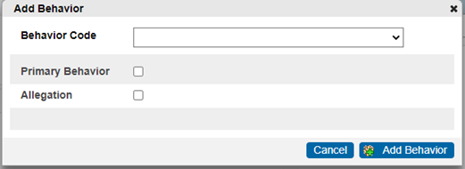

1. Choose the appropriate **Behavior Code** from the pop-up menu and then choose the appropriate behavior subcode from the subsequent menu, if applicable.

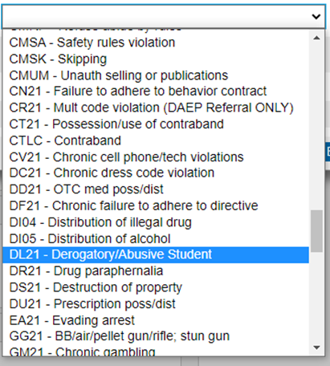

1. Select the **Primary Behavior** checkbox if this is the primary behavior for the incident. If the incident has multiple behaviors, the most egregious behavior should be checked as the Primary Behavior.

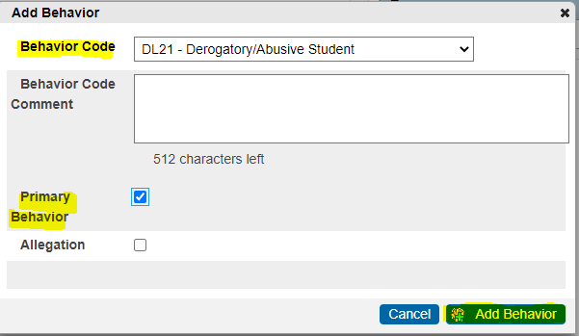

1. Click **Add Behavior**. The behavior appears under the Incident Elements heading.
2. Click and drag the behavior to the appropriate offender. The behavior appears under the name of the offender and also remains listed under Incident Elements. The primary behavior is reported for each incident.

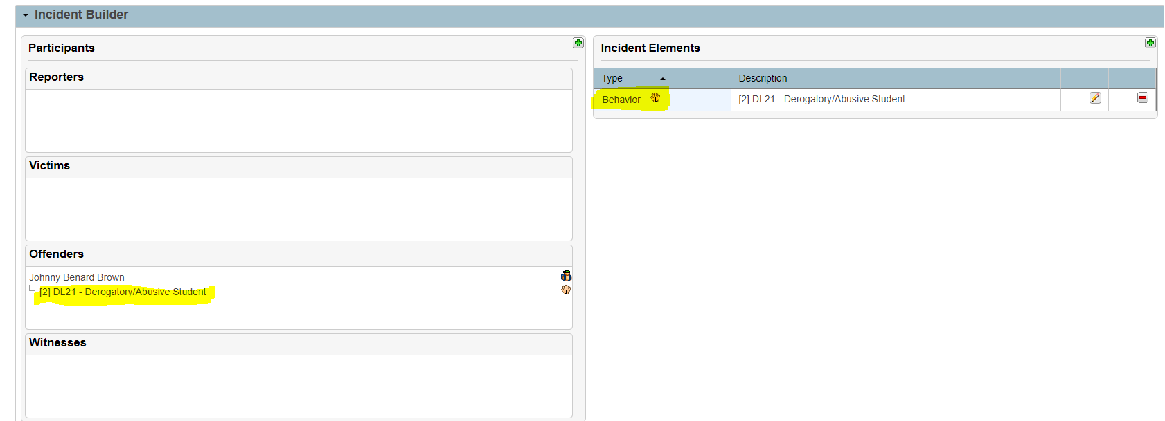

1. Add Action in the next section.

Note: If multiple people on the same incident have the same Behavior code and the same Behavior Location code, only one behavior needs to be added. However, the behavior must be associated with each participant. Click and drag the behavior to each applicable participant.

***Add an Action***

Use the steps below to add actions to the incident.

**Required for state and federal reporting**: Action Code, Action Date Range, Duration Code, Assigned Duration, Actual Duration. If the Action is for a placement, Campus of Assignment is required. For CRDC reporting, Action Attributes are required if applicable.

1. Click the **Plus (+)**button next to Incident Elements.
2. Choose **Add Action** from the pop-up menu.

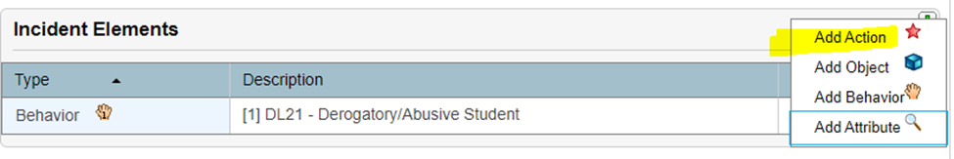

1. Choose the appropriate **Action Code** from the pop-up menu. Then choose the appropriate behavior subcode from the subsequent menu, if applicable.

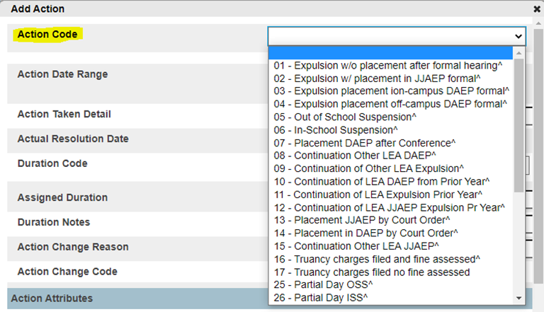  
An additional field,**Action Code Comment**, displays depending on the selected Action Code.

1. Enter the **Action Date Range** (Begin Date & End Date). The Date of Disciplinary Action is pulled from the Begin Date.
2. Populate the **Action Taken Detail** with information regarding the action taken by the district/school in response to the incident.
3. Enter the **Actual Resolution Date**this is date is not required or reported to PEIMS.
4. Select the appropriate **Duration Code, this is the difference reason code.**  
   An additional field, **Duration Code Comment**, displays depending on the selected Duration Code.

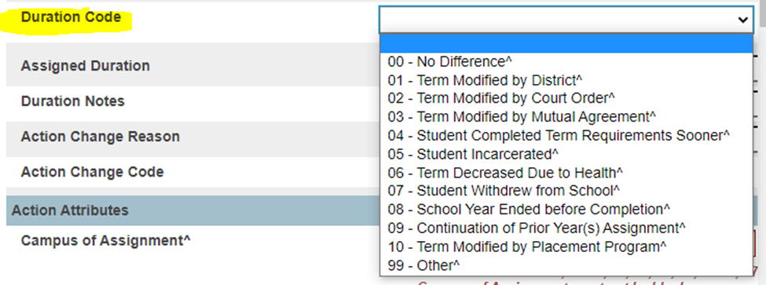

1. Enter the **Assigned Duration (# of days assigned)** and the **Actual Duration (# of days completed).**

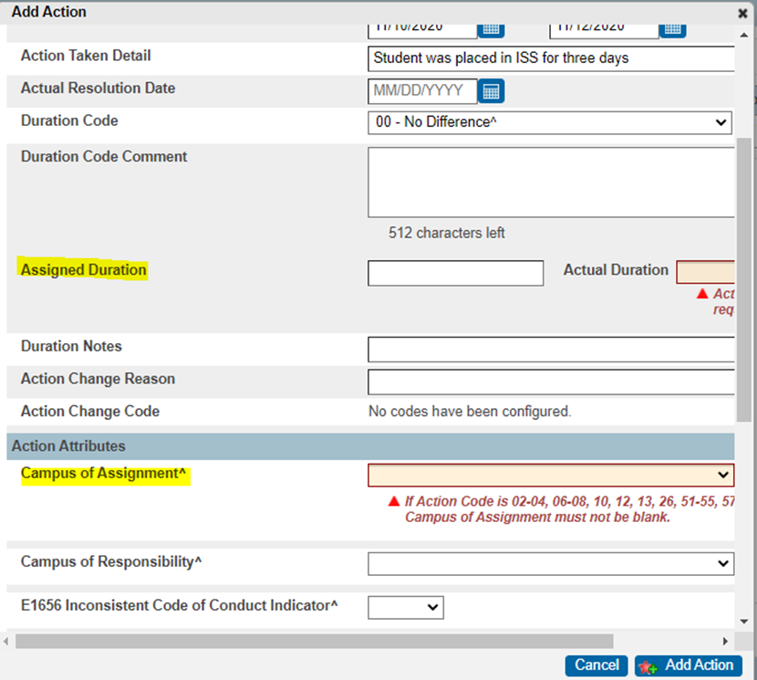

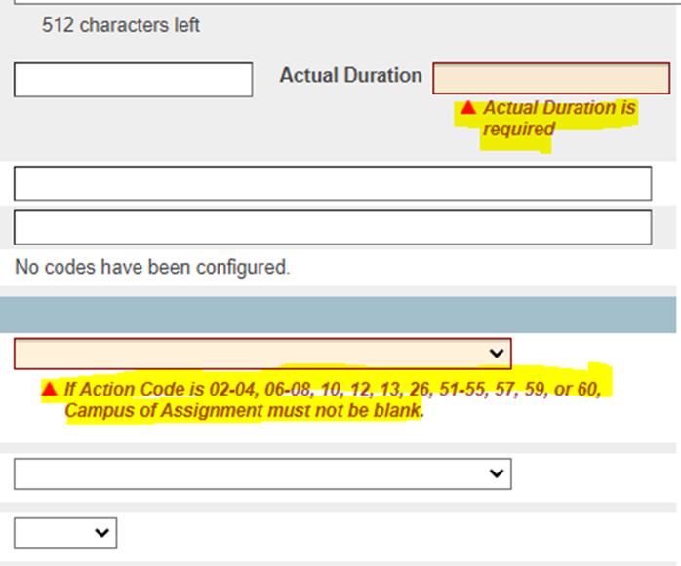

1. Enter the **Campus ID of Assignment**, **Campus of Responsibility** if applicable. Enter **Inconsistent Code of Conduct Indicator** - Yes or No.

TEA Definition: INCONSISTENT-CODE-OF-CONDUCT-INDICATOR-CODE indicates whether an out-of-school suspension, disciplinary alternative education program placement, or expulsion action is inconsistent with a local education agency’s student code of conduct.

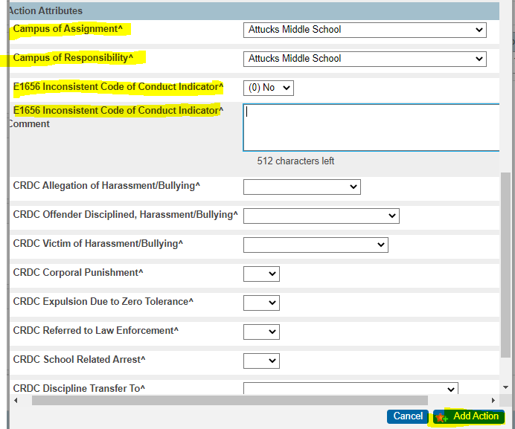

1. Add additional information as applicable.
2. Choose the **Action Attribute(s)** as applicable for PEIMS and CRDC reporting. Each field listed below includes a comment field that displays when the action attribute is populated.
3. Click **Add Action**. The action appears under the Incident Elements heading.
4. Click and drag the action to the appropriate behavior or participant. The action appears under the behavior or participant and is no longer listed under Incident Elements.

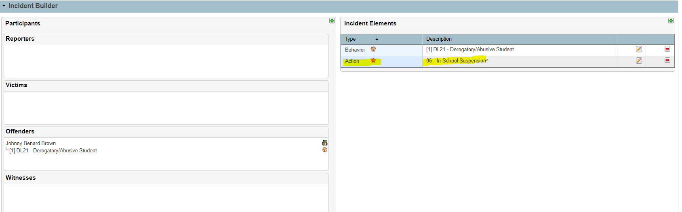

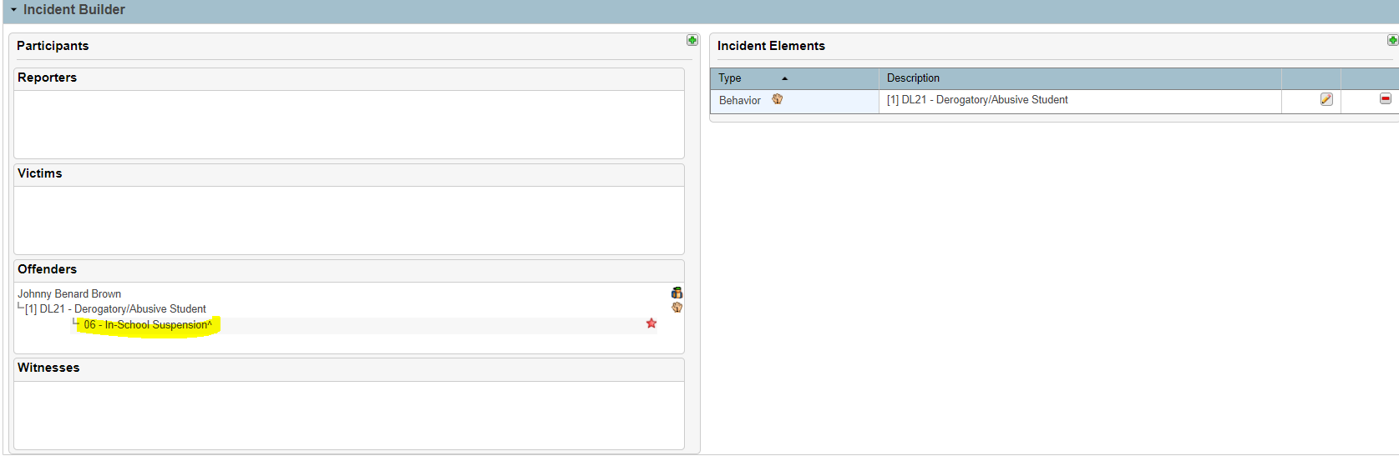

1. Click **Submit Incident** to save the changes. Once you click submit it will take you back to the Incident Management home page.

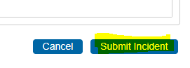

Incident Management Home Page

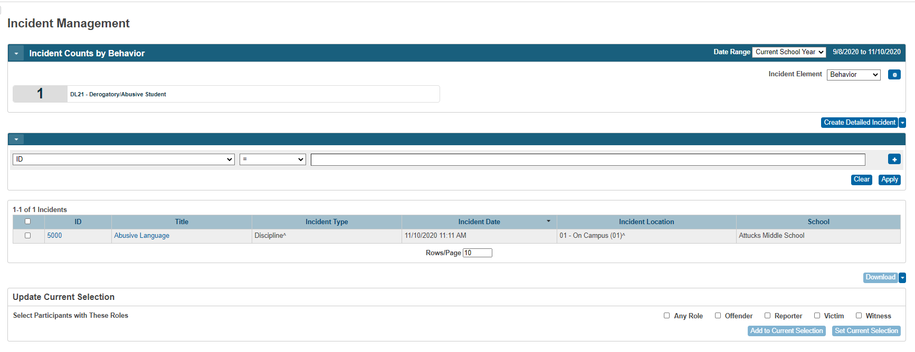

Vocabulary: PEIMS and HISD Connect fields for Incident Management.

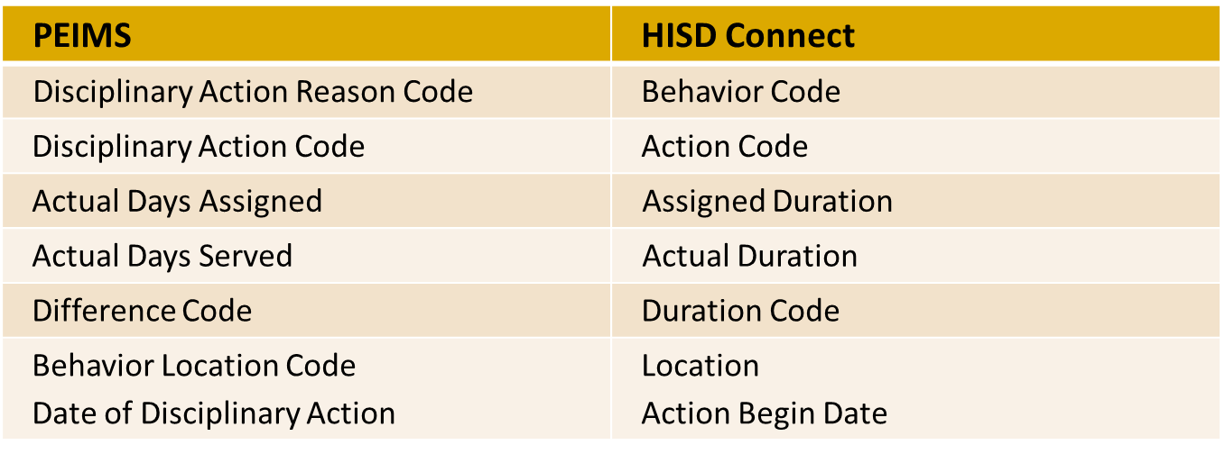

NOTE: When entering a Bullying Allegation you will use CRDC Victim which is where you would you enter attributes. 

**Add Other Participants**

Use these steps to add a participant who is not in the PowerSchool system.

**Note:** The state does not collect data on other participants.

1. Click the **Plus (+)**button next to Participants. The Search for Student, Staff, or other Participants dialog appears.
2. Click **Create Other**.
3. Populate the First, Middle, Last names, position, age, and gender fields. This information should be defined, if known, for both Offenders and Victims, but is not needed for Witnesses. Reporters do not need to be defined.
4. Click **Add**.
5. Click the **Plus (+)**button under Attributes. A Participant Attribute code pop-up menu appears.
6. Choose the appropriate **Participant Attribute code** from the menu.
7. Click **Add Participant Attributes**. An additional field,**Participant Attribute Subcodes**, will display depending on the selected Attribute Code.
   1. As needed, populate the **Attribute Code Comment.**
8. Choose a role from the **Select Role(s)** pop-up menu. There must be at least one **Offender** per incident.
9. Click **Update Participant Attributes.**
10. Either add additional incident elements or click **Submit Incident** to save the changes.